Think Tank MATE ROV - TMS

Date: 6/5/2025
Researcher(s):
Ryan Moore

Objective of research:

To analyze 7 technical reports for the 2024 pioneer-class teams and take notes of TMS relevant design choices and other relevant information.

Notes:

Allan Hancock College
- General
  - Not much information 🤷
  - 10.5 kg
  - Used Eagle Ray Kit
  - Used Wetlink penetrators for cable bulkheads into electronics housing
- Construction
  - HDPE Frame
    - Good buoyancy properties
  - Lots of 3d printed parts
    - Spacers, shrouds, end caps
- Thrusters
  - 4
    - 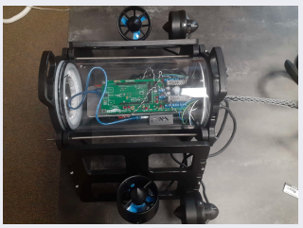
    - 2 pointing upward
    - 2 pointing back
  - Extra holes on frame for alternate mounting spaces.

Clovis Community College
- General
  - 14.5 kg
- Construction
  - All based around a central acrylic tube
  - 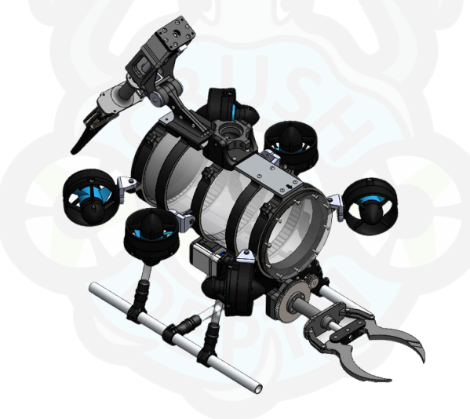
  - ABS Filament
    - Strength to weight ratio
    - Lots of 3d printed parts
- Thrusters
  - 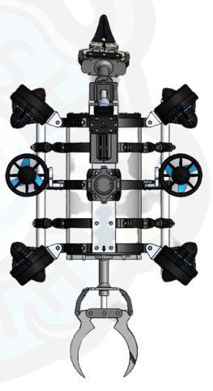
  - Six
    - 4 forward/back rotated somewhat to allow for rotation
    - 2 to move upwards
- Grippers
  - 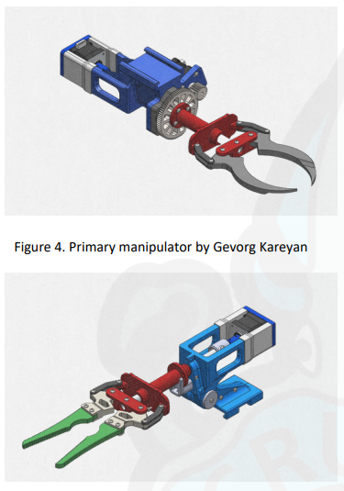
  - Lead screw driven
- Tether
  - Used landscape lighting wire for high durability and flexibility
  - Foam rope added to tether so that tether does not influence ROB’s buoyancy
- Buoyancy
  - 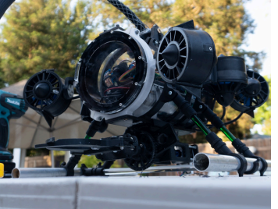
  - Steel tubes filled with adjustable steel rods mounted to bottom of ROV to tune balance and ballast

Edmonds Community College
- General
  - ½“ PVC frame
  - Used Barracuda Kit
  - Used a Wii controller?
  - PETG Fillament
- Tether
  - Brightly colored for visibility
- Cameras
  - Coated in epoxy and encased in acrylic cylinders
- Thrusters
  - 4
  - 3d printed guards
- Buoyancy/Ballast
  - Closed cell foam on top
  - Weights on bottom

Embry-Riddle Aeronautical University
- General
  - 16.2 kg
  - Aluminum outer frame
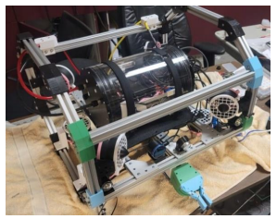
- Lots of 3d printing
  - Pla for prototyping
  - PETG for electronics stuff
  - PLA for final external parts
- Thrusters
  - 8
    - 4 vertically
    - 4 horizontally
- Camera
  - Used (expensive af) waterproof cameras

- Tether
  - Two 8 awg power cables
  - One blue robotics Fanthom Tether

University of Applied Sciences Esslingen
- General
  - Triangular shape
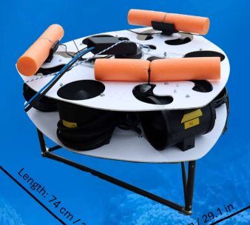
  - Changeable “toolsled” on top to facilitate quick tool changes
- Thrusters
  - 6
    - 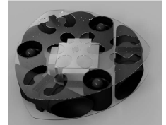
    - 3 downwards
    - 3 out each side
- Buoyancy
  - Positive buoyancy
  - Thrusters used to actively descend
- Gripper
  - 3
    - 2 forward facing “pliers”
    - 1 fingered gripper
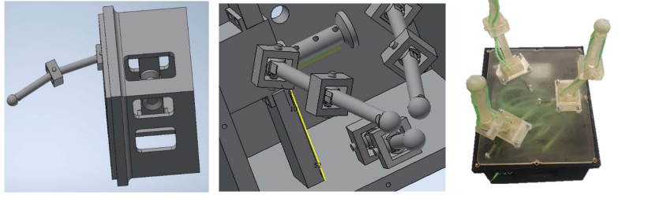
- Cameras
  - Usb cameras coated in epoxy
- Electronics box
  - Cast aluminum box?
  - 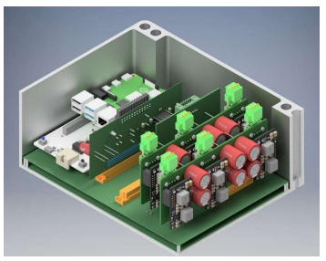
  - They had many issues getting the casting into a dimensionally accurate product
Estrella Mountain Community College
- General
  - 14.7 kg
  - Used Eagle Ray Kit
  - HDPE Frame
  - Nothing revolutionary about their ROV 🤷
- Thrusters
  - 3d printed shrouds
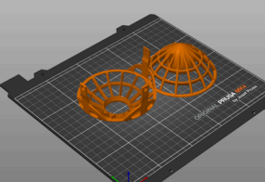
- 4
  - 2 upwards
  - 2 sideways

Leonardo de Vinci University
- General
  - 8.23 kg 🤯
  - PLA filament
  - Used polycarbonate for electronic tube
  - Threaded rod/nut construction makes main structure and holds end caps
  - Aluminum and 3d printed parts for external parts
  - 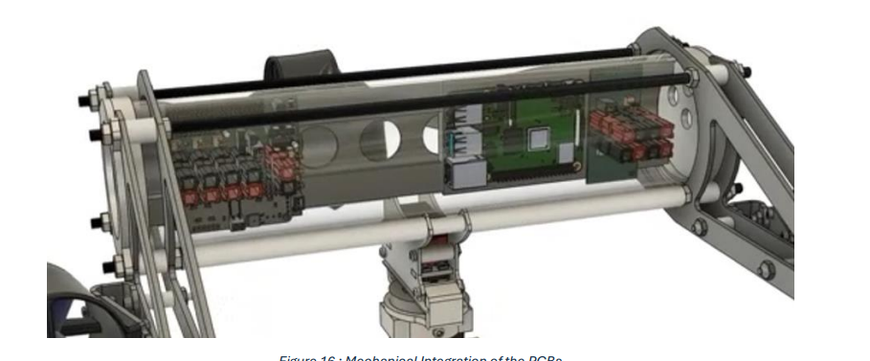
- Thrusters
  - 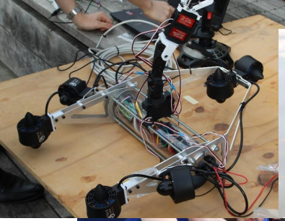
  - 6 in a unique layout similar to the University of Applied Sciences
- Arm
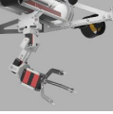
- 5 axis arm
- 3 claw gripper
Sources:
List all sources used for later reference and proper citation.

